**Problem 2**

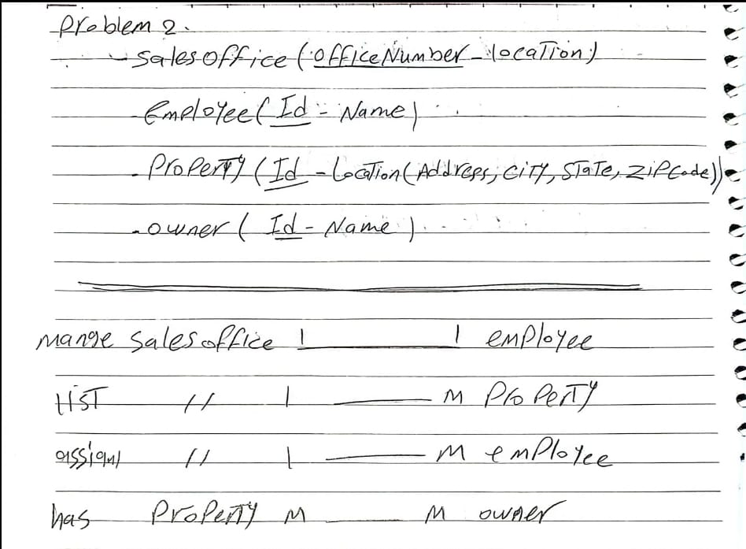

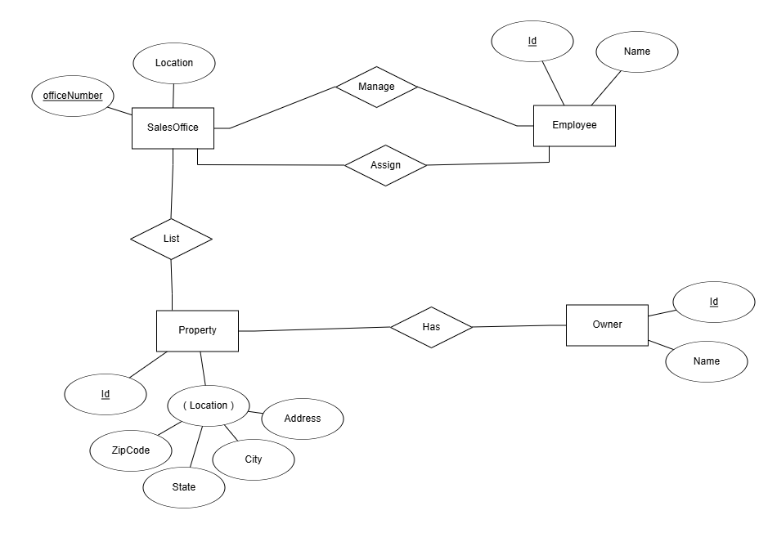

1

1

M

1

1

M

M

M

Real Estate tables

|  |  |
| --- | --- |
| OfficeNumber | location |
| 1 | Downtown |
| 2 | cairo |
|  |  |

1. SalesOffice Table
2. Employee Table

|  |  |
| --- | --- |
| Id | Name |
| 33 | Ahmed |
| 22 | Sara |
|  |  |

3- Property Table

|  |  |  |  |  |
| --- | --- | --- | --- | --- |
| Id | Adress | City | State | ZipCode |
| 1 | 123 Elm St. | New York | NY | 10001 |
| 2 | 232osa ve | Cairo | CA | 9002 |
|  |  |  |  |  |

1. Owner Table

|  |  |
| --- | --- |
| Id | Name |
| 1 | Omar |
| 2 | Saad |
|  |  |